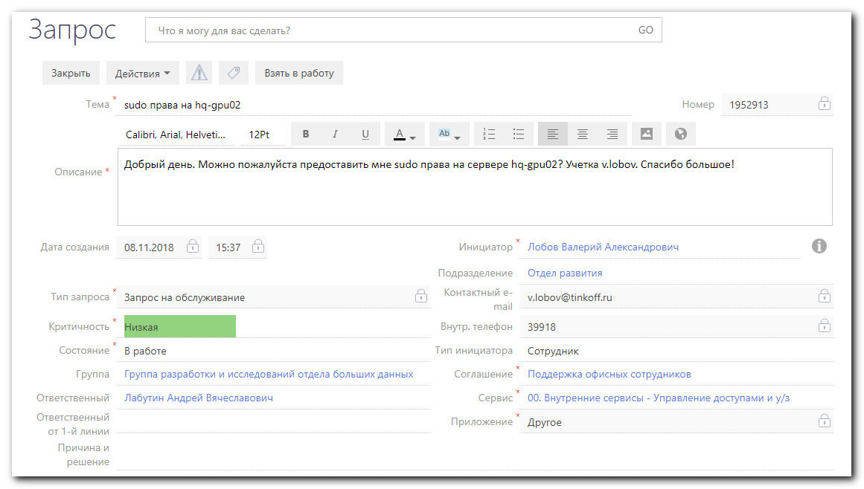
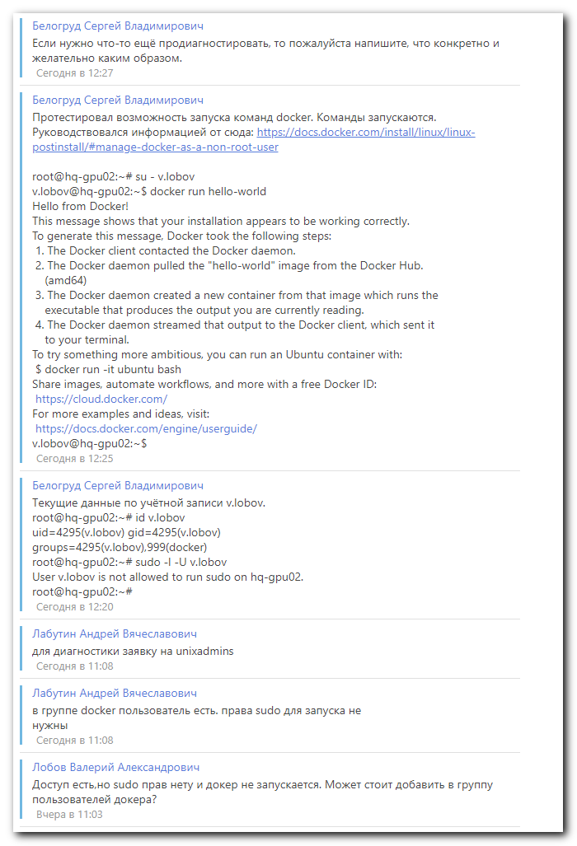

https://docs.docker.com/install/linux/linux-postinstall/

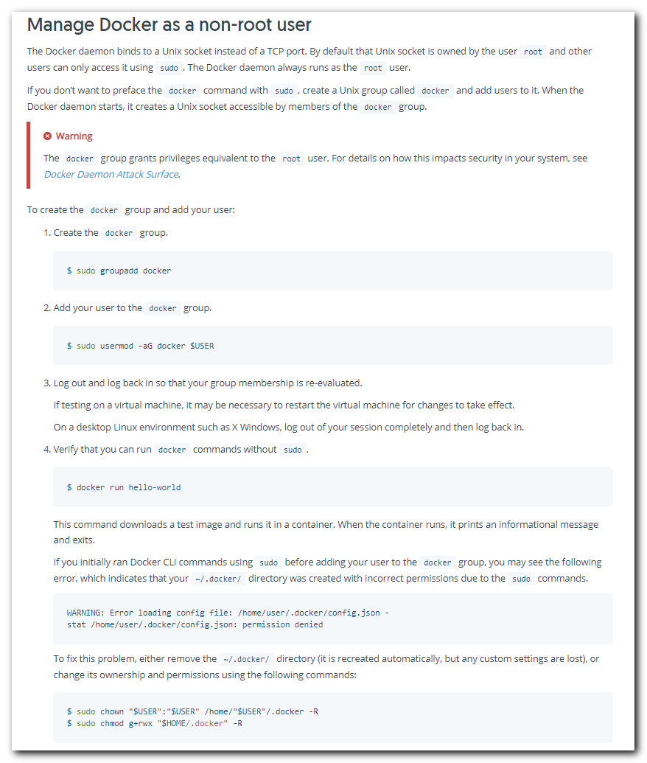

https://askubuntu.com/questions/477551/how-can-i-use-docker-without-sudo

